# OR test 1 last year

1. 4x + 6y <= 8 is
   1. a linear equation
   2. a linear inequality
   3. a nonlinear equation
   4. a nonlinear inequality
2. In simplex method , we add ‐‐‐‐‐‐‐‐‐‐‐‐‐‐‐‐ variables in the case of ‘=’.
   1. slack variable
   2. surplus variable
   3. artificial variable
   4. none of the above
3. Which of the following is not necessarily part of a linear programming problem?
   1. Objective function
   2. decision variable
   3. linear constraint
   4. nonlinear constraint
4. The solution of x + y <= 8 and 2x + 4y <= 20 is
   1. x=4, y=4
   2. x=2, y=6 (y=2,x=6 when solved)
   3. the system has infinite solutions
   4. the system has no solution
5. If you wish to solve x + y + z = 8 and 2x + 4y + z = 20. The system has
   1. Unique solution
   2. infinite solutions
   3. no solution
   4. exactly two solutions
6. The maximum value that 5x + 6y can take provided x and y satisfy 0<x<=8 and 10<= y<20 is
   1. 0
   2. 40
   3. 80 x=4 y=10
   4. 160
7. 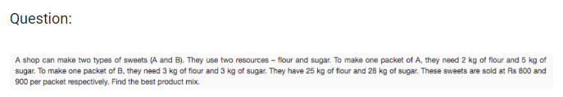
   1. The appropriate objective function for this problem is to
      1. maximize total revenue
      2. minimize total cost
      3. maximize the total units of products produced
   2. The number of decision variables is .......... (fill only the integer value)
   3. The number of constraints is .......... (fill only the integer value)
8. 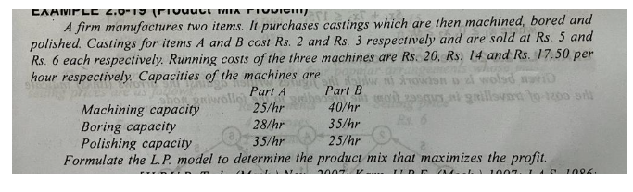descriptive question
9. 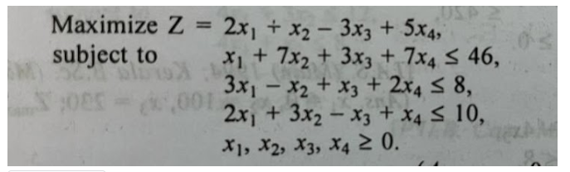solve lp problem